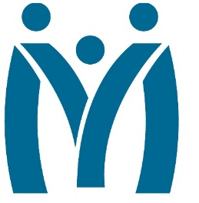

Metropolitan Human Services District
Board of Directors Meeting
Friday, December 16, 2022 | 11 AM
3100 General DeGaulle Drive, New Orleans, LA 70114

MHSD fulfills its statutory role as the planning body for the behavioral health, addiction and intellectual/developmental disability services for the residents of Orleans, Plaquemines and St. Bernard Parishes by ensuring that eligible residents in these parishes have access to person centered and recovery focused supports designed to optimize their role in the community.
Agenda

- Call to Order

- Attendance

- Approval of the October 26, 2022 Minutes

- Monitoring Reports
  - Monthly Dashboard
    - Telehealth report
    - Services Comparison last 2 FYs
  - Fiscal Report
  - Other Reports
- Report on Incidents FY23 1Q
- Ends Report FY23 1Q

- Decision Information

- Consent Agenda

- Self-evaluation: Board Performance Review

- Adjourn

